Customer lifetime value and retention Analysis

- Project Overview
Business often struggles to identify the most valuable customers and understand whether customer remain engaging over time.
This project used RFM Segmentation, Customer Lifetime value (CLV), and Cohort Analysis to identify high-value customers, analysis customer behavior pattens, and measure customer retention performance. This insight can help business improve customer retention, personalize marketing efforts, and prioritize high value customers to maximize long term revenue.

- Objectives
- Identify high value customer segments using RFM analysis.
- Calculate customer lifetime value (CLV) to measure customer profitability.
- Analyze customer purchasing behavior through recency, frequency, and monetary spending patterns.
- Measuring customer retention using cohort analysis.
- Identify opportunity to improve customer retention and customer loyalty.
- Provide data driven recommendation to increase customer lifetime values and retention.

3 Dataset Overview
Ecommerce Transactions Dataset

Size
- 541,909 transactions
- 4,322 unique customers
- Date Range 2012-2011

3 Key Fields
Field | Description
Customer ID | Customer identification
Invoice No | Transaction Number
Invoice Date | Purchase Date
Quantity | Item Purchased
UnitPrice | Product Price
Revenue | Quantity * UnitPrice

4 Tools Used
Tool | Purpose
Python | Date Cleaning, RFM Analysis & CLV, Cohort Analysis
Panda | Data Manipulation
Tableau | Dashboard Development

5 Data Preparation
- Removing missing with missing Customer IDs.
- Converted InvoiceDate to datetime format.
- Created Revenue Column (Quantity * Unit Price).
- Remove invalid transaction and records.
- Create snapshot data for RFM analysis.
- Prepared cohort tables for retention analysis.

6 RFM Analysis
RFM Metrics
Metrics | Description
Recency | Days since customer’s last purchase
Frequency | Number of purchases made
Monetary | Total amount spent by the customer

7 Customer Lifetime Value (CLV)
Methodology
- CLV was calculate using each customer total historical revenue.
- Customer were segmented into:
- VIP
- High Value
- Medium Value
- Low Value
Purpose
- Identify customers who generate the highest revenue
- Support customer retention and loyalty initiatives.

8 Cohort Analysis & Retention
Purpose
- Group customers based on a first purchase month.
- Measure customer retention over time.
- Identify Trends in customer engagement and repeat purchasing behaviour.
Metrics
- Cohort Month
- Cohort Index
- Retention Rate

9 Dashboard Overview
Dashboard 1 Customer value Analysis
This dashboard provides insights into customer segmentation, customer lifetime value, and revenue contribution across customer groups.
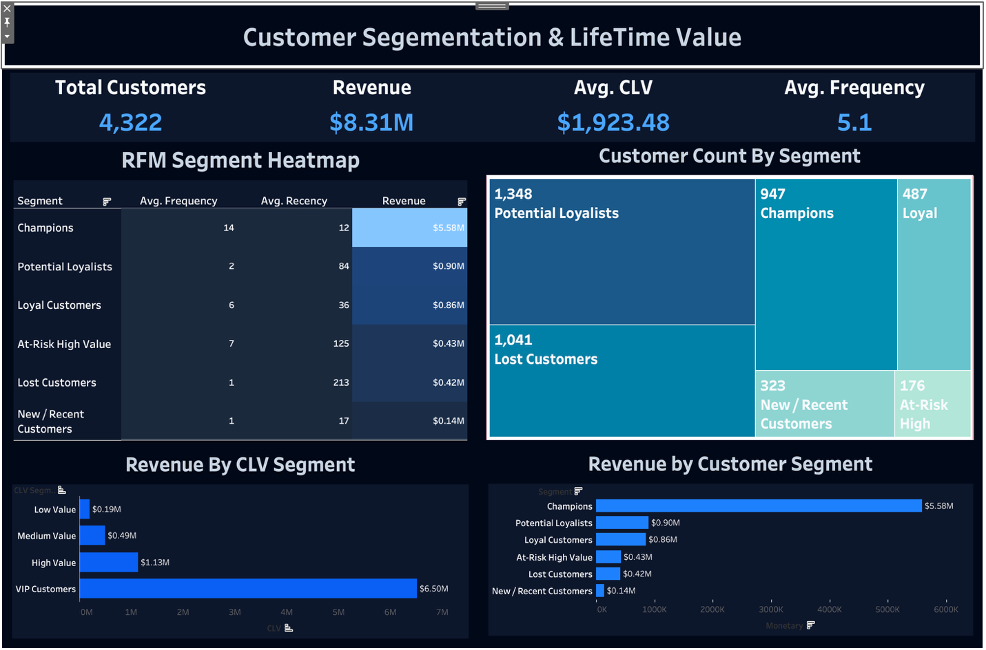
- KPI Card (Total Customer, Revenue, Average CLV, Average Frequency)
- RFM Segment Heatmap
- Customer Count by Segment (Treemap)
- Revenue by Customer Segment
- Revenue by CLV Segment

Dashboard 2 Customer Retention Analysis
This dashboard analysis customer retention patterns using cohort analysis and retention metrics
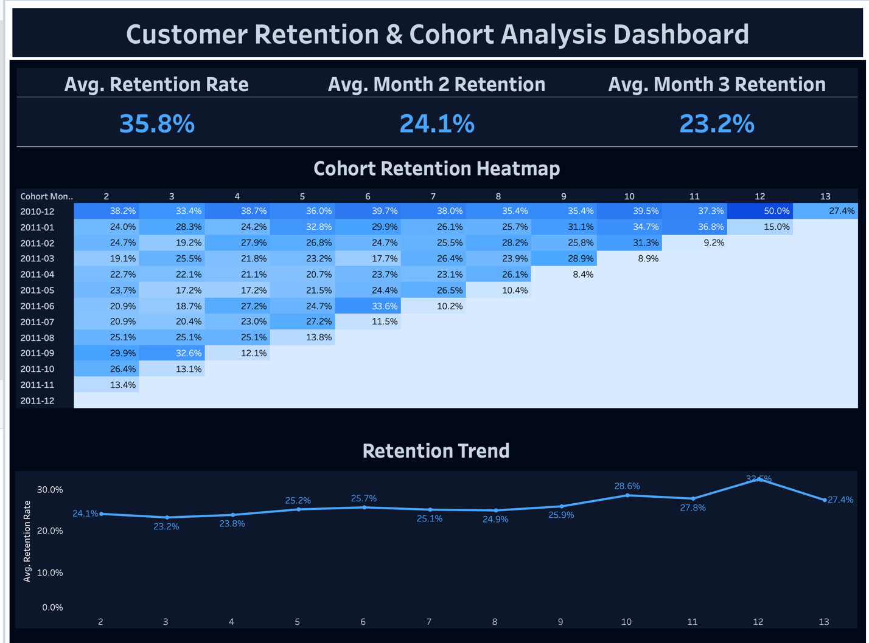

- Average Retention Rate KPI
- Average Month 2 Retention Rate KPI
- Average Month 3 Retention Rate KPI
- Cohort Retention Heatmap
- Retention Trend Analysis

10 Key Findings
- Potential Loyalists represented the largest customer segment with 1,348
Customers, indicating a strong opportunity to increase customer loyalty.
- Champions generated the highest revenue at $5.58M, demonstrating that a relatively small group of customers contributes a significant portion of total revenue.
- VIP customers contributed the highest customer lifetime value at approximately $6.50M, highlighting their importance to the business.
- At Risk High Value Customer generate over $0.43M in revenue but showed declining engagement, presenting a retention opportunity.
- The overall customer retention rate was 35.8% with retention dropping to 24.1% in month 2, indicating customer churn occurs early in customer lifecycle.
- Most cohorts experienced declining retention over time, suggesting the need for strong customer retention strategies.

10 Business Recommendations
- Implement loyalty and reward programs for champions and VIP customer to maintain engagement and maximize customer lifetime value.
- Develop personalize marketing campaigns to convert potential loyalists into long term loyal customers.
- Lunch target re-engagement campaign for At-Risk-High Value and lost customers to recover potential revenue.
- Improve onboarding and post purchase communication during first few months to reduce early customer churn.
- Focus retention and marketing efforts on high value customer segments to maximize revenue and customer lifetime value.
- Monitor cohort retention trends regularly to emulate the effectiveness of customer retention initiatives.

